Guidelines for authors

ICFE2026 |15th International Conference in the field of Education

Creativity, Art and Learning in Digitally Transformed Education
May 27-29, 2026 / University of Zagreb/ Faculty of Teachers Education/ Savska cesta 77, Zagreb, Croatia

Authors who contribute to the conference-book must strictly follow these guidelines. When preparing your conference paper please mind also the following instructions.
Article
- Word-Document: 13 - 15 pages A4 (including abstract, key words, text and references, short information about the author)
- Margin: above, below, right, left: 2.5 cm
- Typographic features: Times New Roman, 16 pt, spacing 22, flush left, no word division
- Charts, tables: must be included in the file and numbered in the order in which they appear in the text (e.g. Table 1. or Figure 1.). Reproduction will appear black-and- white and must be legible in an A5-format
- No footnotes.
Structure /See template below
- TITLE OF THE CONFERENCE PAPER (SMALL CAPITALS, BOLD)
- Author’s name, University/Department, Country
- Abstract (10-12 lines)
- Key words: 3-5
- Divide text into sections (1; 1.1; 1.2; 2. 2.1 ...). Paragraphs not indented
- References
- Information about the author, E-mail address (appr. 4 lines maximum).
Quotation according to APA standard (example):

Shelton (2015) overstated the case when she asserted that “we seem to be reaching (...) from the hands of philosophers” … (p. 218).
References (at the end of the article) according to APA standard:

1. Periodical articles:

Author, A., & Author, B. (publication year). Article title. Journal title, volume number (issue number), page numbers.
Chan, D.W., Cheung, P.-C., Lau, S., Wu, W.Y.H., Kwong, J.M.L., & Li, W.-L. (2001). Assessing ideational fluency in primary students in Hong Kong. Creativity Research Journal, 13(3/4), 359-365.

2. Book:

Author, A. (publication year). Title. Place of publication: Publisher.
Leder, G.C., Pehkonen, E. & Törner, G. (Eds.) (2003). Beliefs. a hidden variable in mathematics education. Boston, MA: Kluwer Academic Publishers.

3. Publications in anthologies:

Author, A. (publication year). Essay or chapter title. In E. Editor (Ed.), Book title (essay or chapter page numbers). Place of publication: Publisher.
Labajo, J. (2003). Body and voice: The construction of gender in flamenco. In T. Magrini (Ed.), Music and gender: perspectives from the Mediterranean (pp. 67-86). Chicago, IL: University of Chicago Press.

4. Internet resources:

For electronic and online materials, include stable URL or database name. Include (the author if possible) title and date published when available. For undated materials, include the date the resource was accessed.

National Renewable Energy Laboratory. Biofuels. Retrieved May 6, 2015 from http://www.nrel.gov/learning/re_biofuels.html
Please keep in mind!
Charts, tables: must be included in the file and numbered in the order in which they appear in the text (e.g. Table 1. or Figure 1.). Reproduction will appear black - and - white and must be legible in an A5-format

Final Paper Submission Deadline: 30 th July 2026

Registration and Conference fee payment Deadline: 15 th May 2026

TITEL OF THE CONTRIBUTION
Author’s name
University/Faculty, Country

Abstract
approx. 200 words
approx. 200 words
approx. 200 words

Keywords: 3 – 5

1 Introduction

Divide text into sections (1.; 1.1.; 1.2.; 2. 2.1 ...); (Paragraphs not intended)

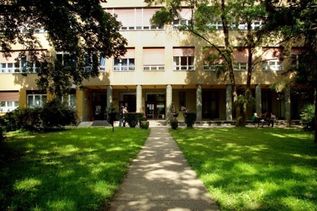

Figure 1. Faculty of Teacher Education Zagreb

Table 1. Results
2 Definition of research problem

2. 1 Methods

2.2 Research sample

2. 3 Measuring instrument and research questions

3 Results and interpretation

4 References

Abouth Authors

Information on author(s), e-mail address(es) (maximum 5 lines per person)

